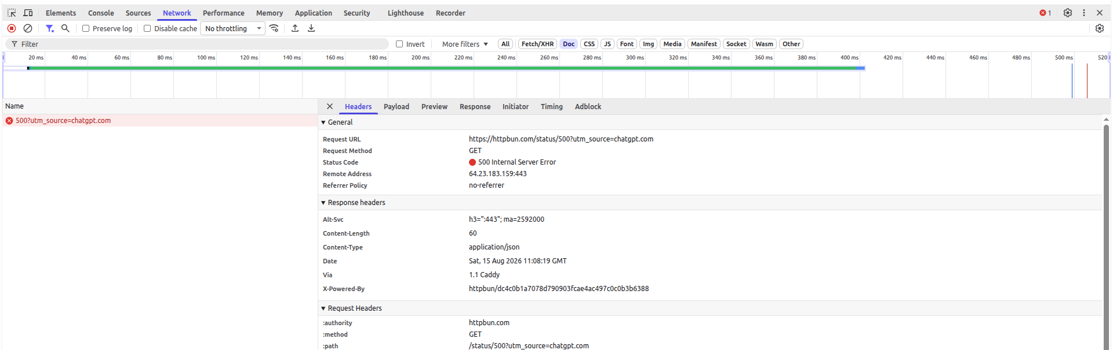
500 Internal Server Error — Server Error
The server encountered an unexpected problem while processing the request.

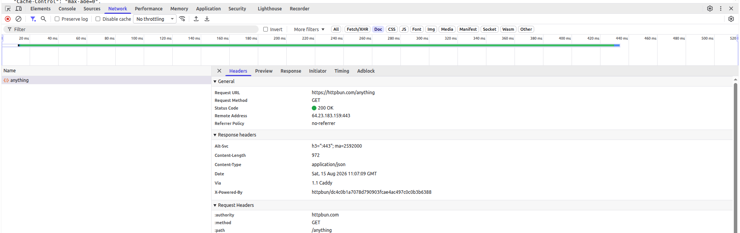
200 OK — Success
The request was successfully processed by the server.

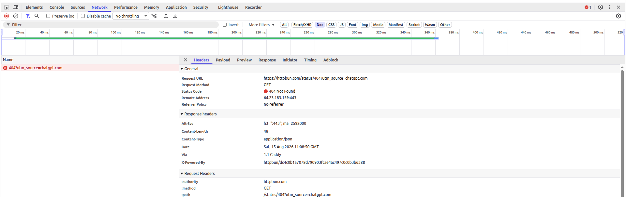404 Not Found — Client Error
The server could not find the requested resource.

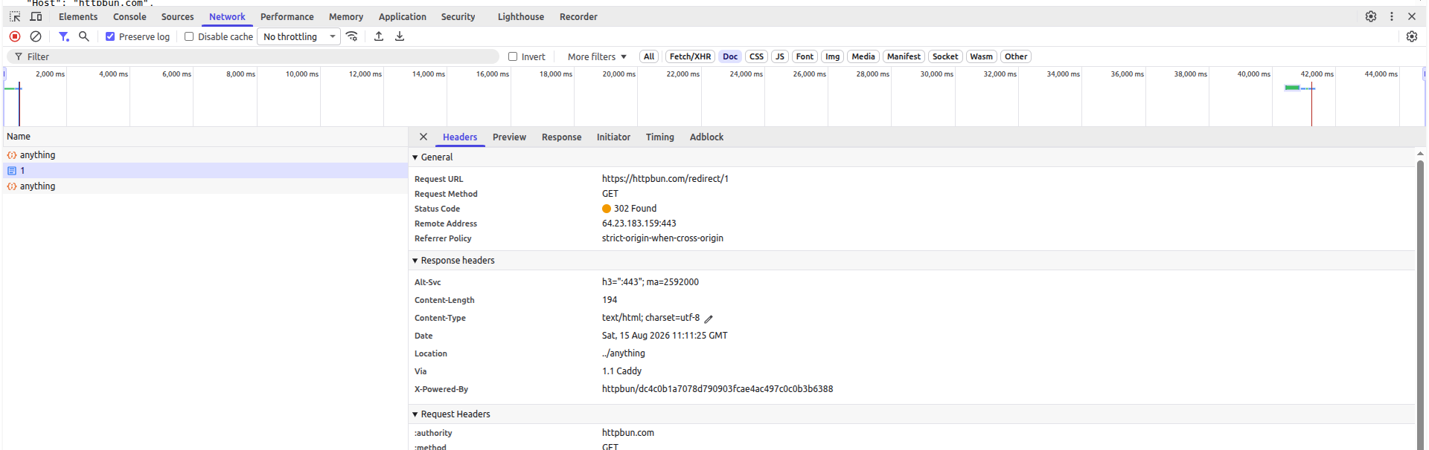302 Found — Redirection
The requested resource is temporarily available at another URL.

